WAF Evaluation — Tables Only
ModSecurity with OWASP CRS • DVWA target • OWASP ZAP 2.17.0

1. Mixed Traffic Summary
Metric | Result
Total Requests | 600
Normal Requests | 120
Normal Allowed | 92
Normal Blocked (False Positives) | 28
Malicious Requests | 480
Malicious Blocked | 480
Malicious Allowed (False Negatives) | 0
Access Denied Events | 1,076
Table 1 — Mixed traffic run summary (n = 600).
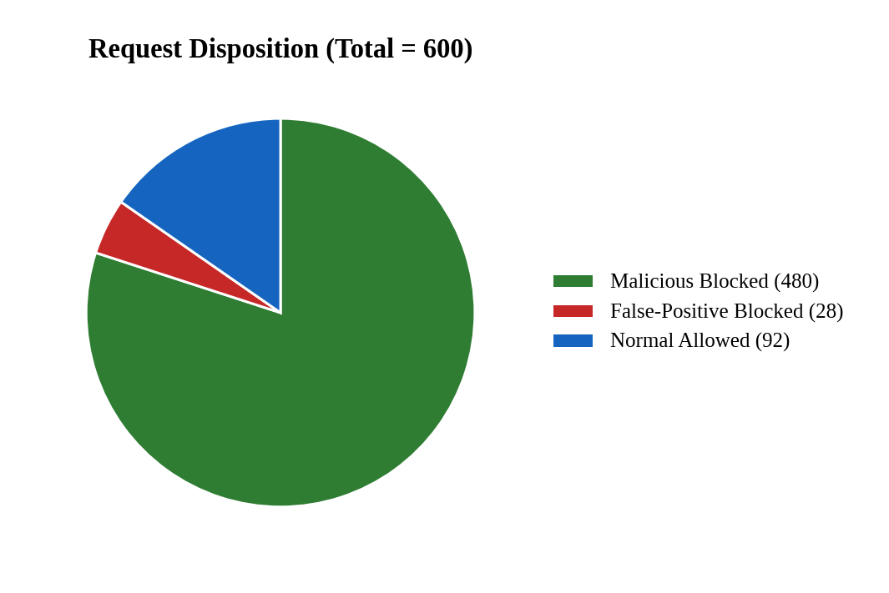
Figure 1 — Request disposition across the mixed-traffic run.

2. Detection Effectiveness Metrics
Metric | Value
Attack Block Rate | 100.00%
False Positive Rate | 23.33%
False Negative Rate | 0.00%
Table 2 — Headline detection metrics.
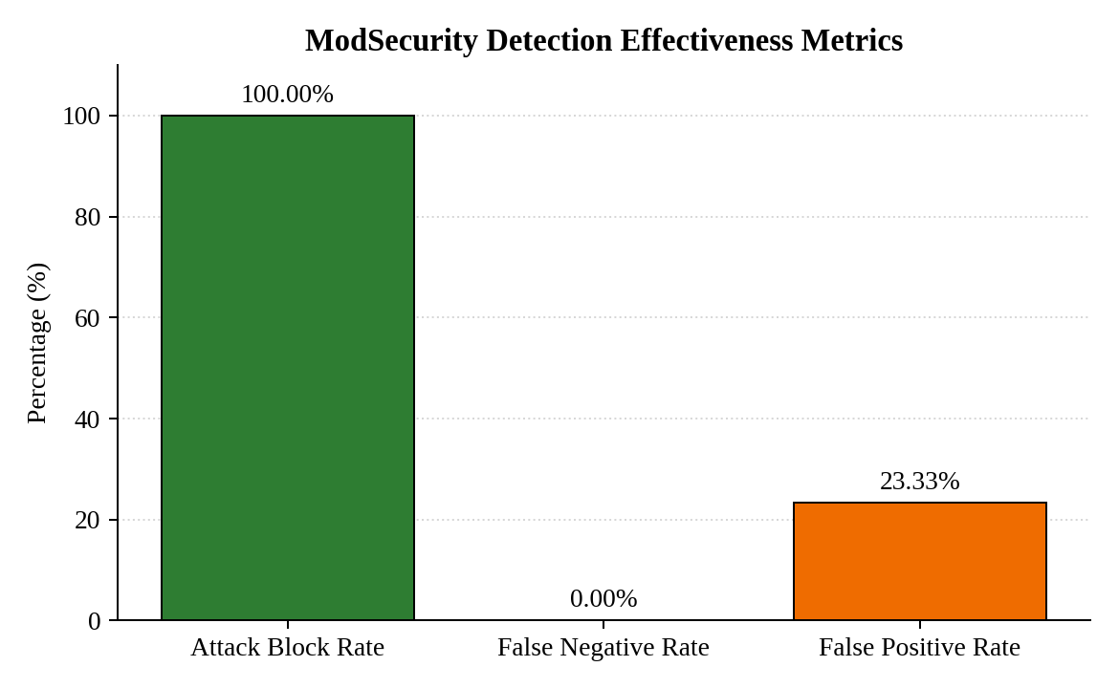
Figure 2 — Headline detection effectiveness metrics.

3. Attack Report Table
Attack Type | CRS Group | Blocked | Allowed | Detection Rate | FN Rate
SQL Injection | 942 | 300 | 0 | 100.0% | 0.0%
XSS | 941 | 300 | 0 | 100.0% | 0.0%
Path Traversal | 930 | 300 | 0 | 100.0% | 0.0%
Command Injection | 932 | 300 | 0 | 100.0% | 0.0%
Table 3 — Per-attack detection results (n = 300 each).
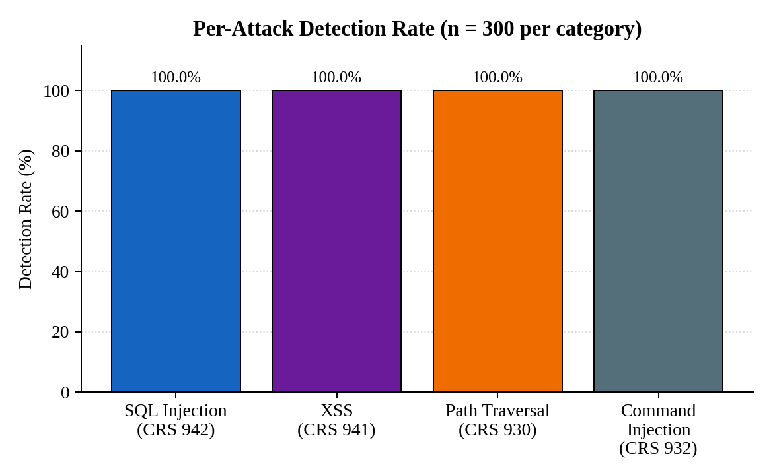
Figure 3 — Per-attack detection rate.

4. CRS Rule Activity
CRS Rule Group | Hits | Share
CRS 941 (XSS) | 1,009 | 19.5%
CRS 942 (SQL Injection) | 1,784 | 34.4%
CRS 930 (Path Traversal / LFI) | 1,768 | 34.1%
CRS 932 (Command Injection) | 626 | 12.0%
Total | 5,187 | 100.0%
Table 4 — OWASP CRS rule group activity.
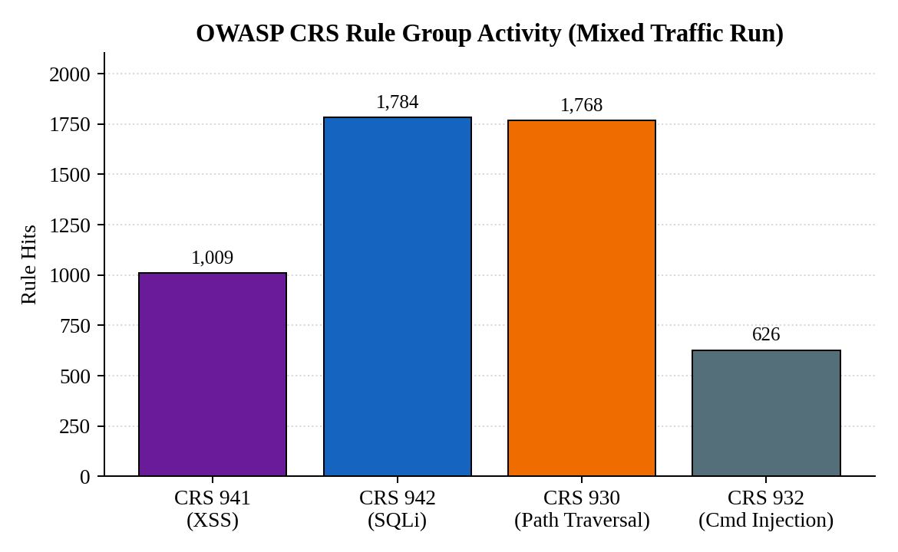
Figure 4 — CRS rule group activity.

5. Classification Matrix
Actual \ Outcome | SQLi | XSS | Path Trav. | Cmd Inj. | Normal | Blocked (FP)
SQL Injection | 120 | 0 | 0 | 0 | 0 | 0
XSS | 0 | 120 | 0 | 0 | 0 | 0
Path Traversal | 0 | 0 | 120 | 0 | 0 | 0
Command Injection | 0 | 0 | 0 | 120 | 0 | 0
Normal | 0 | 0 | 0 | 0 | 92 | 28
Table 5 — Classification matrix for the mixed-traffic run.
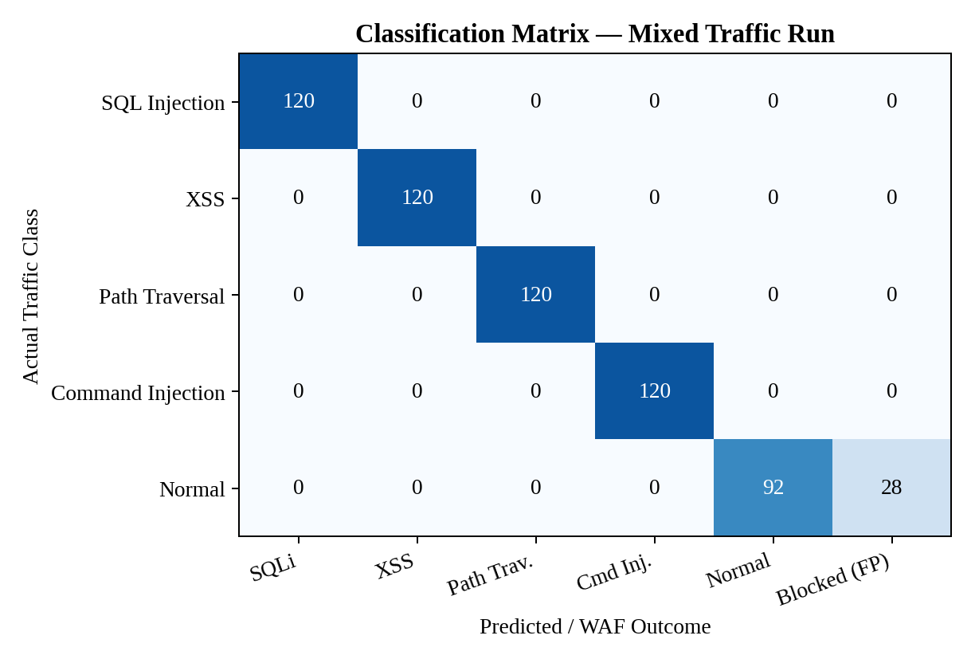
Figure 5 — Classification matrix heatmap.

6. SQLi Replay Summary
Metric | Result
Total Requests | 304
Blocked Requests | 304
Allowed Requests | 0
Detection Rate | 100%
False Negative Rate | 0%
CRS 942 Rule Matches | 13,025
Access Denied Events | 2,604
Table 6 — SQLi replay pipeline results.

